1 IP Addresses are the way in which computers talk to each other. Every machine on the internet can be identified by its unique or Public IP Address. When we connect machines together we do this in a Network. Each computer in your network will have a unique IP address, and this will be within a range of numbers determined by a subnet mask. To find out the IP address of your machine you can open a Command Prompt and type the command

ipconfig

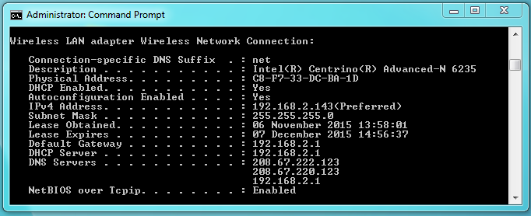

*Look for the tag* ***IPv4 Address***

*If your Pi is connected to the same network it will have a similar address. When you know its IP Address you will be able to connect to it.*

2 To find out your Pi’s **Internet Protocol (IP) Address** you will need to open a terminal window. The first time you try to do this you will need to do this with a monitor, mouse and keyboard (because you will not know the IP Address of your Pi!). You will need to open a **Terminal** and get to the command prompt on the Pi. Once you have a Pi command prompt, run the command:

$ sudo ifconfig –a

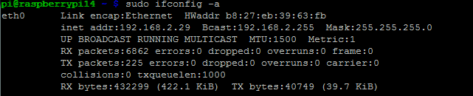

*Look for the tag* ***Internet Address****. You should be connected to the same network, or you can connect your machine directly to the Pi with an Ethernet Cable.*

! “sudo” is a command that allows a normal user to execute a command using the same privilege as a root user.

3 You can create your own network by connecting the Pi directly to your machine using an Ethernet cable and configuring a Static IP address

! Static IP Addresses are ones that do not change. They can be set manually on your device. Dynamic IP Addresses are allocated by a DHCP server on your network, at home this function is provided by your Service Provider’s Wifi Router.

4 First you will need to set your machine with a a static IP address and network mask. Open the network configuration and set your Local Area Connection to the **xxx.xxx.xxx.1** address of the same network. In the example above we are on a 192.168.**3**.0 network.

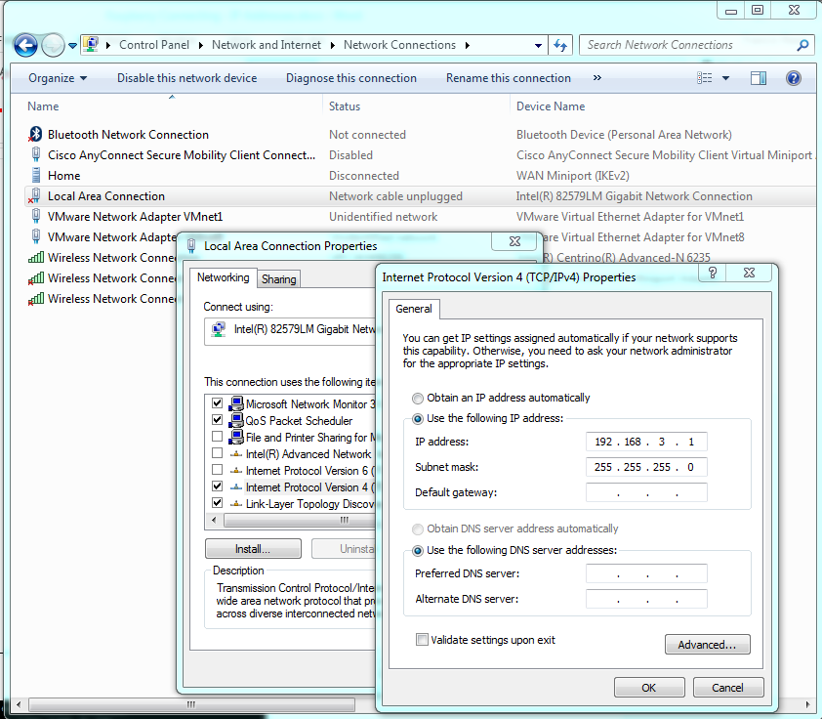

*Ensure your Ethernet Cable is plugged in to your machine and the Pi. Look for the* ***IP Address*** *in the properties of your* ***IPV4*** *address of your* ***Local Area Connection****. Then manually set the IP Address to 192.168.3****.1*** *and the Subnet Mask to* ***255.255.255.0***

5 Now you have to do the same with your Pi. The commands are different, this time you have to edit a file with the following command.

sudo nano /etc/network/interfaces

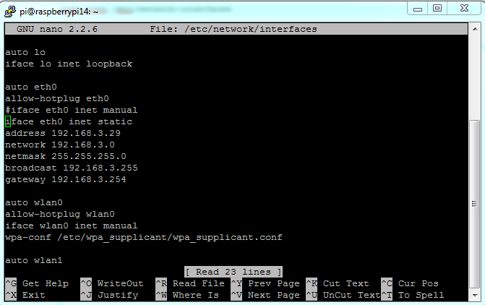

***Set the parameter iface to static, and add parameters for address, network, netmask, broadcast and gateway. Save the changes and exit.***

6 Now reboot your Pi to apply the changes

sudo reboot

7 Now test you can reach your Pi. Open a **Command Prompt** on your local machine and try to communicate with the Pi using the **ping** command using the IP Address you used in step 2.

ping 192.168.3.29

*Make sure you get a Reply from the Pi and not a timeout!*

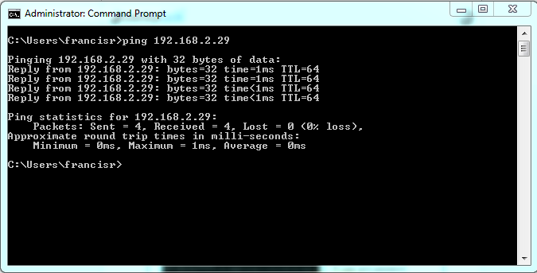

More information about setting IP Address on your Pi can be found at:

<http://www.modmypi.com/blog/tutorial-how-to-give-your-raspberry-pi-a-static-ip-address>